**PROJECT- 1:**

**AIM: To create an EC2 Linux instance.**

EC2 Service (Elastic Compute Cloud):

* EC2 is a core service offered by Amazon Web Services (AWS) and falls under the category of Infrastructure as a Service.
* It provides virtual servers in the cloud, allowing users to create and manage compute resources.
* EC2 offers a highly scalable and flexible computing environment.
* EC2 offers several pricing options to accommodate different needs.
* EC2 seamlessly integrates with other AWS services, enabling users to build comprehensive and scalable applications.
* EC2 provides various tools and features to simplify the management and monitoring of instances. Users can use the AWS Management Console, Command Line Interface (CLI), or SDKs to control and configure instances.

Setting up an EC2 Linux instance:

Steps:

1.First we need to launch an instance. So, we need to provide our instance a name.

2.We Should select the AMI as ubuntu 22.04 LTS.

* In AWS (Amazon Web Services), AMI stands for Amazon Machine Image. An AMI is a pre-configured template that contains the necessary information to launch an instance (virtual server) in the AWS cloud. It includes the operating system, software, and any additional data required to run an application.

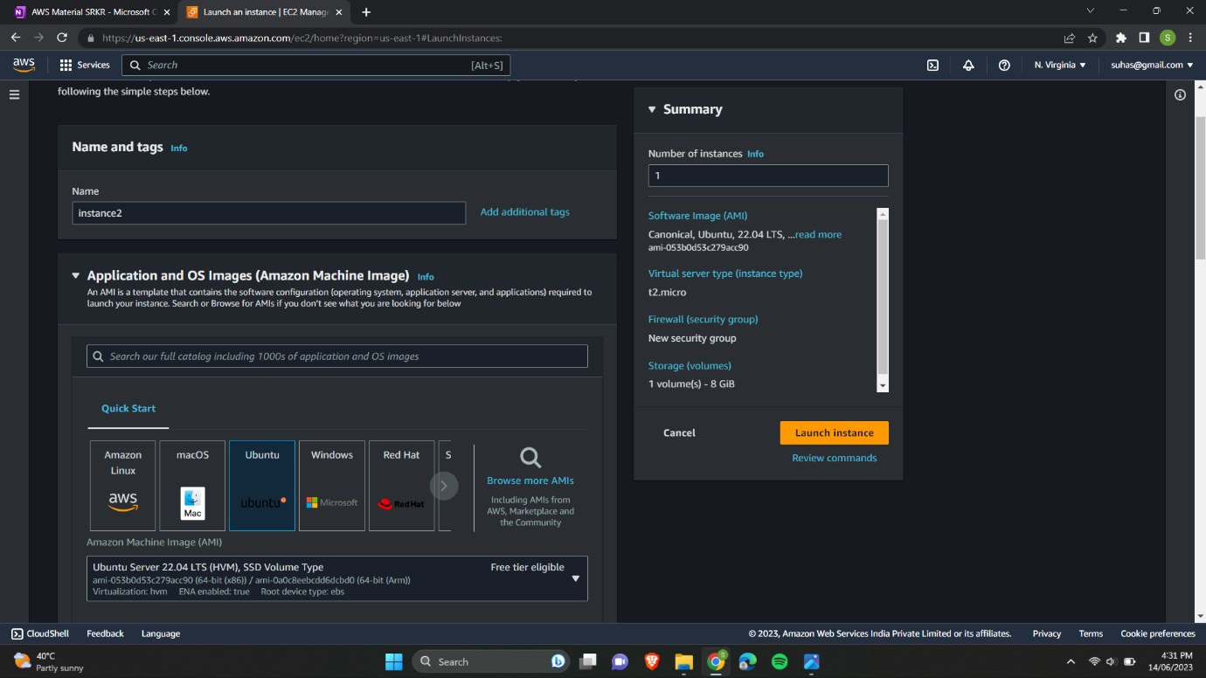

3.Selecting the instance type as t2.micro and selecting the keypair.

* In AWS (Amazon Web Services), an instance type refers to a specific configuration of virtual hardware resources that are allocated to an Amazon EC2 (Elastic Compute Cloud) instance. Each instance type has varying combinations of CPU, memory, storage, and networking capacity to meet different workload requirements.
* In AWS (Amazon Web Services), a key pair is a secure key-based authentication method used to securely connect to instances running in Amazon EC2 (Elastic Compute Cloud). It consists of a public key and a corresponding private key.

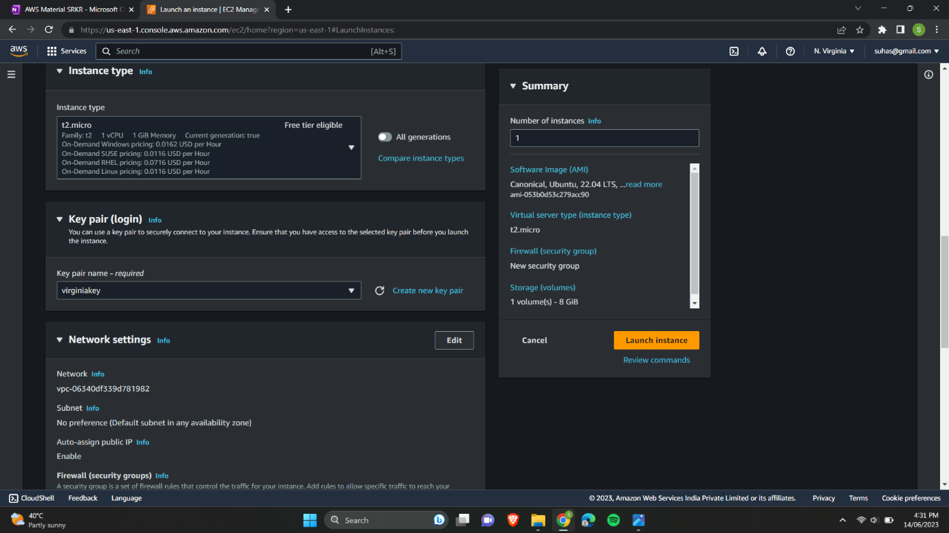

4.We are going to edit the network settings and configuring the security group.

* In AWS (Amazon Web Services), a security group is a fundamental component of network security that acts as a virtual firewall for your EC2 (Elastic Compute Cloud) instances. It controls inbound and outbound traffic to and from your instances.
* In this case we are only allowing SSH and HTTP requests.

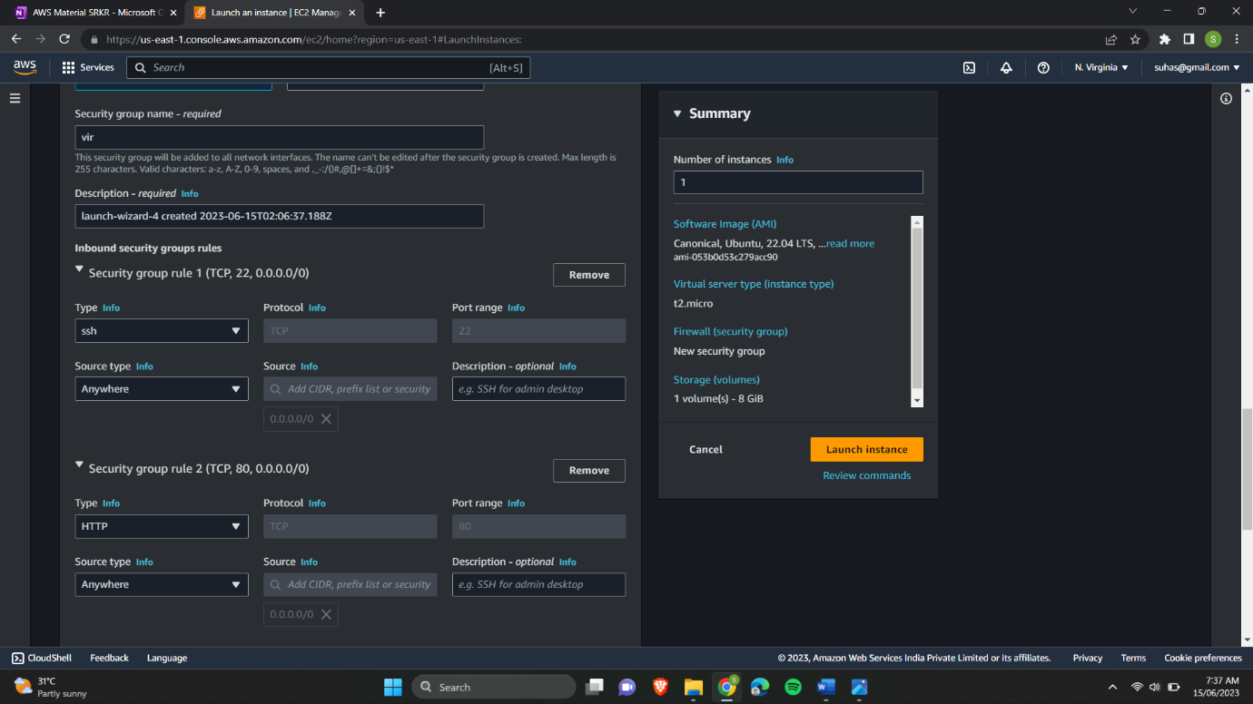

5.After launching the instance it is visible as below.

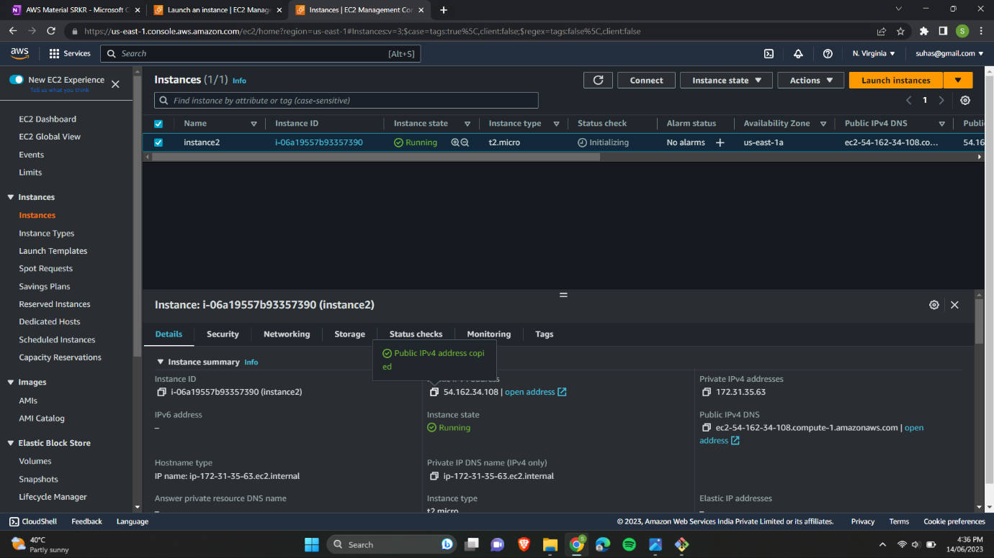

6.Now starting the gitbash and changing the directory to desktop where our keypair file(.pem) is present.

7.Changing the permissions of the file to allow only read operation for all. And connecting our instance by using gitbash.

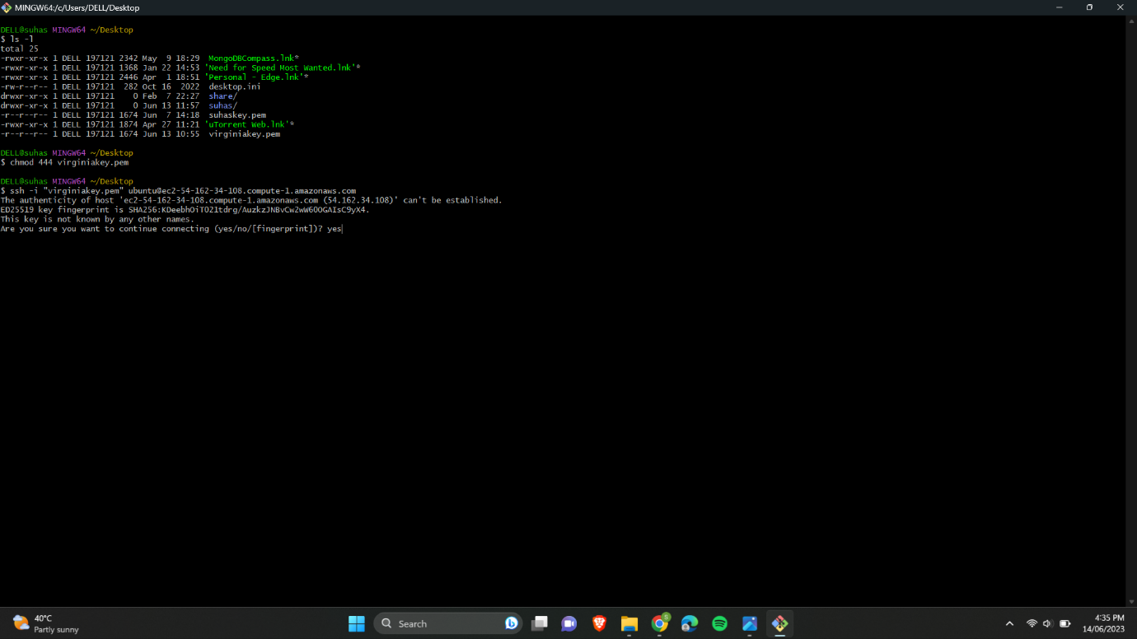

8.Updating our ubuntu and installing apache2 server.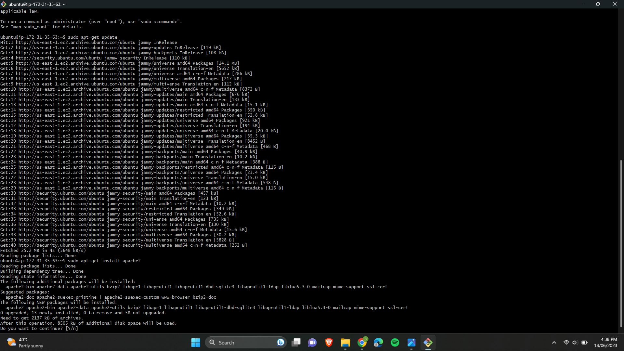

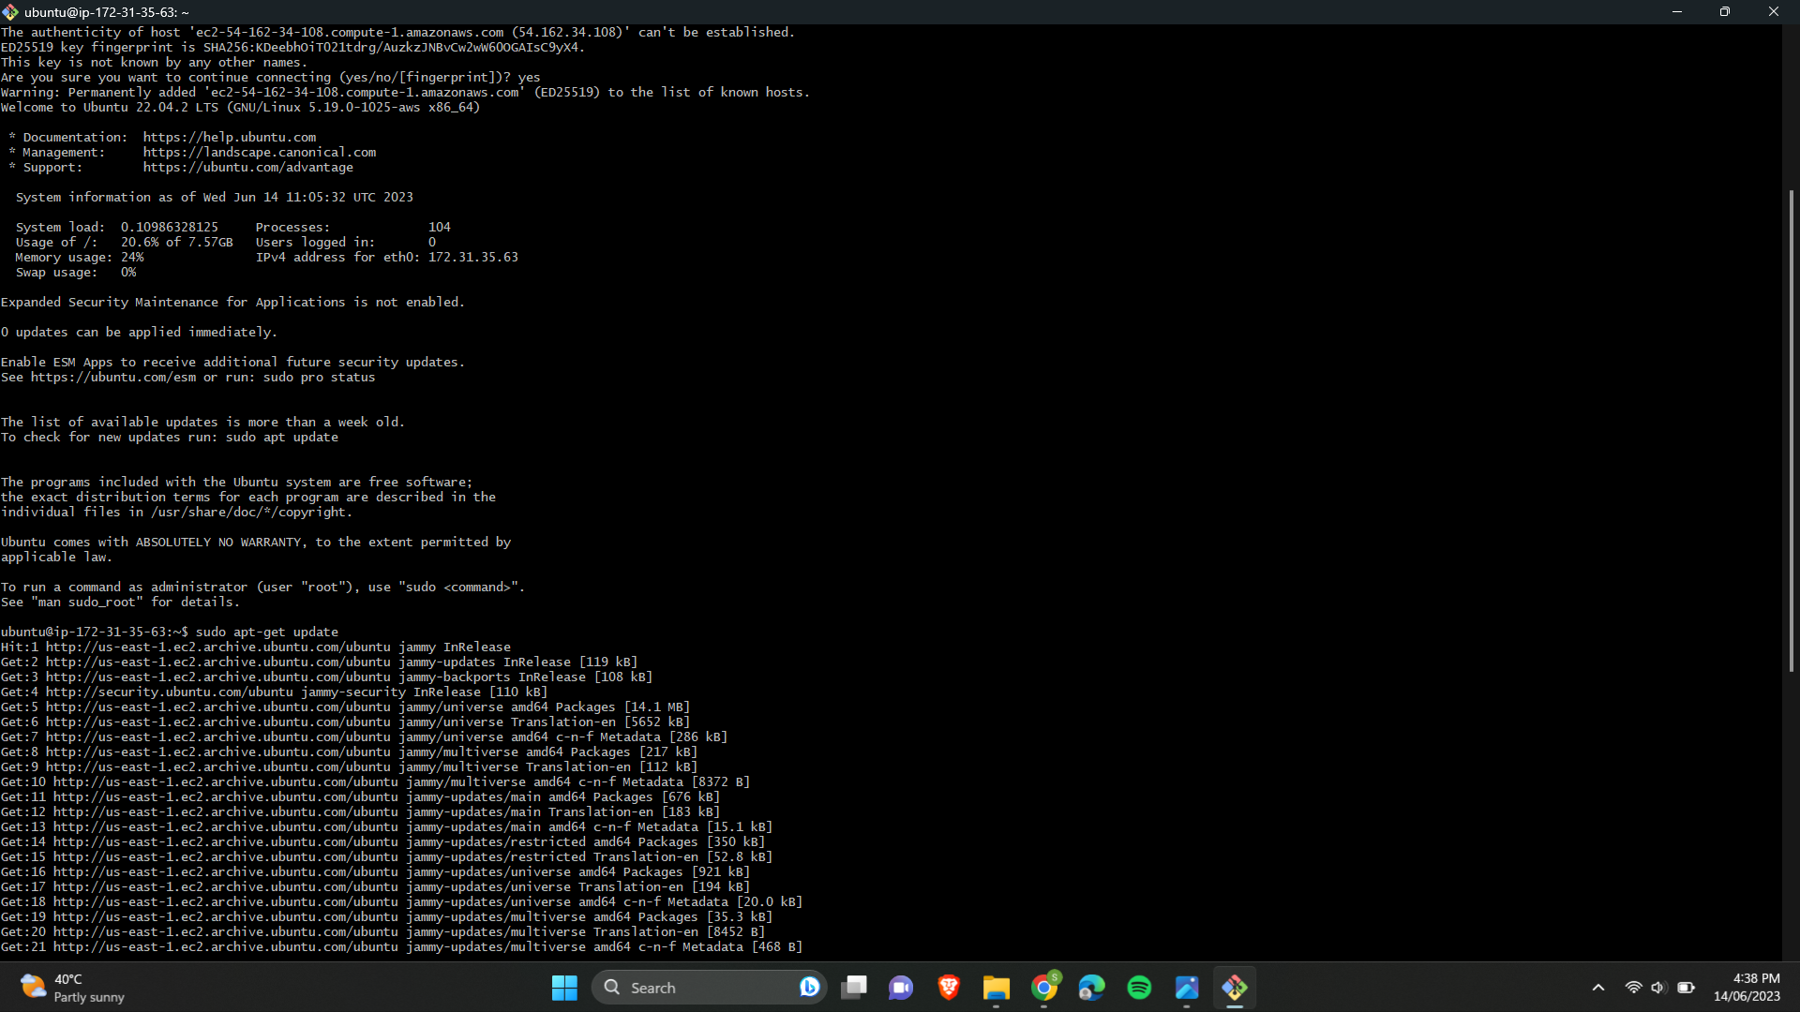

9.Now visiting the public IP of our instance in the browser we can see the default apache2 page.

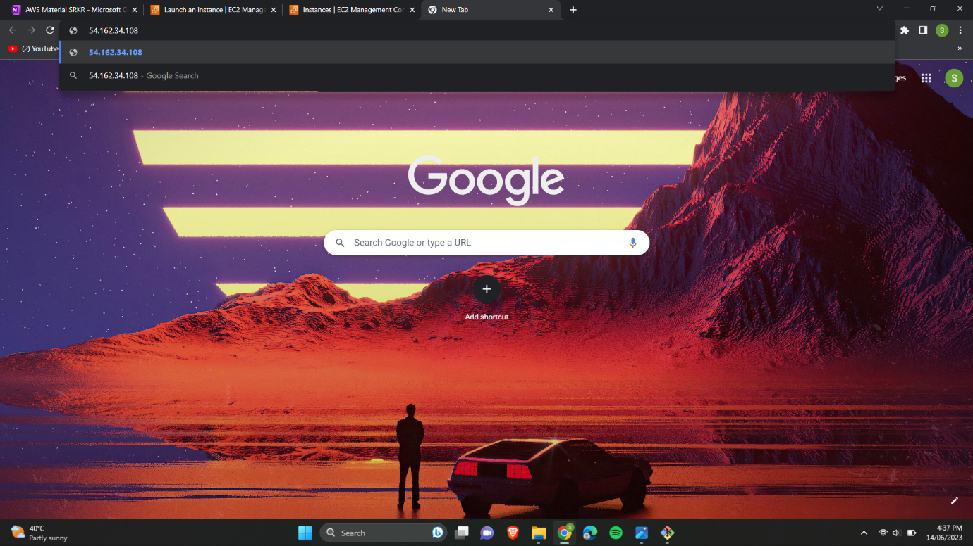

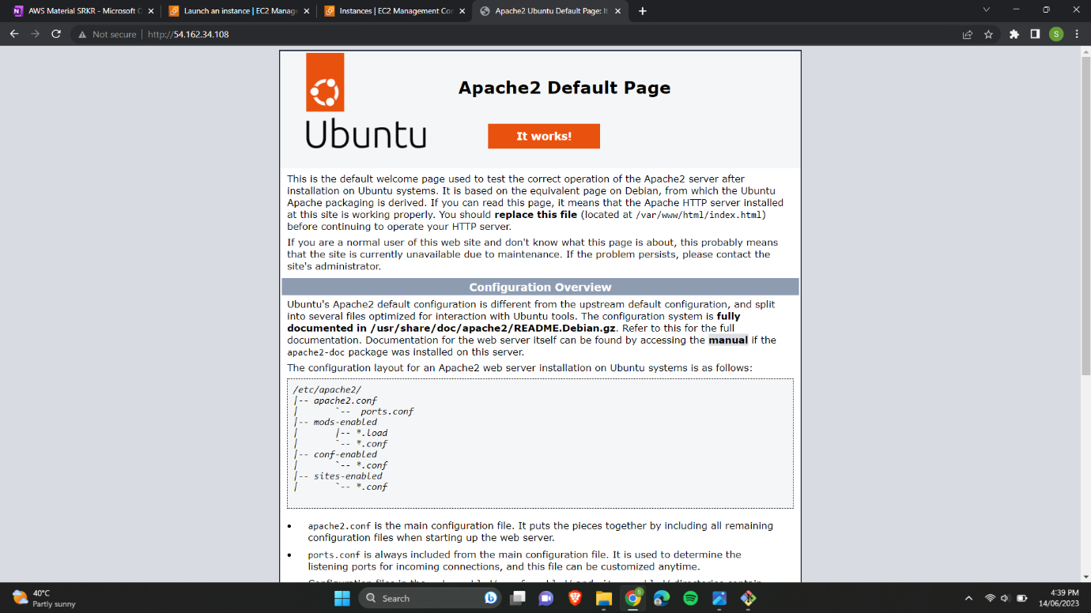

By replacing the file located at /var/www/html/index.html file we can host our website.

Creating an image (AMI) for our existing instance.

Steps:

1.Selecting our instance which is in running state and selecting image and template option.

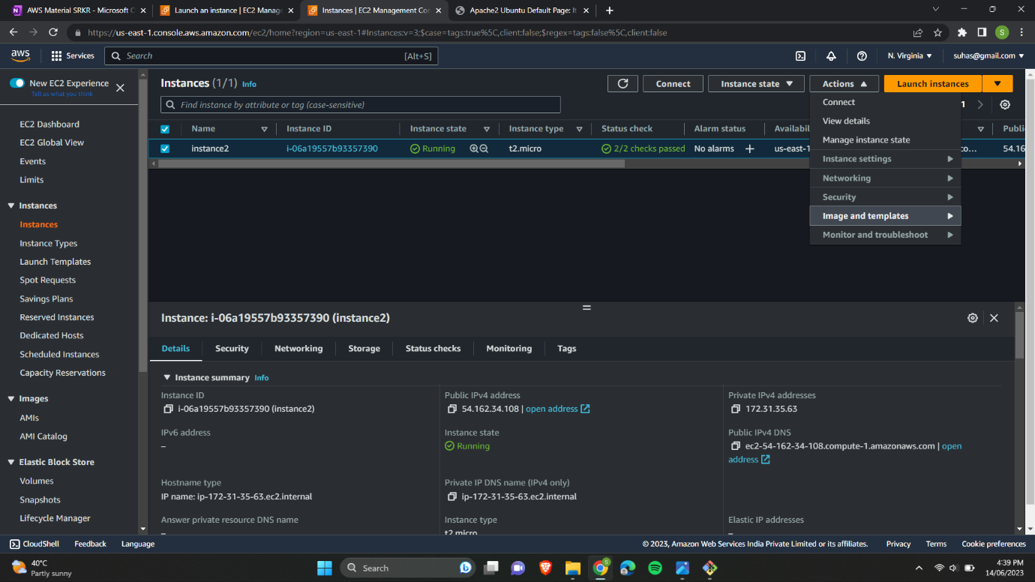2.Then selecting create image option.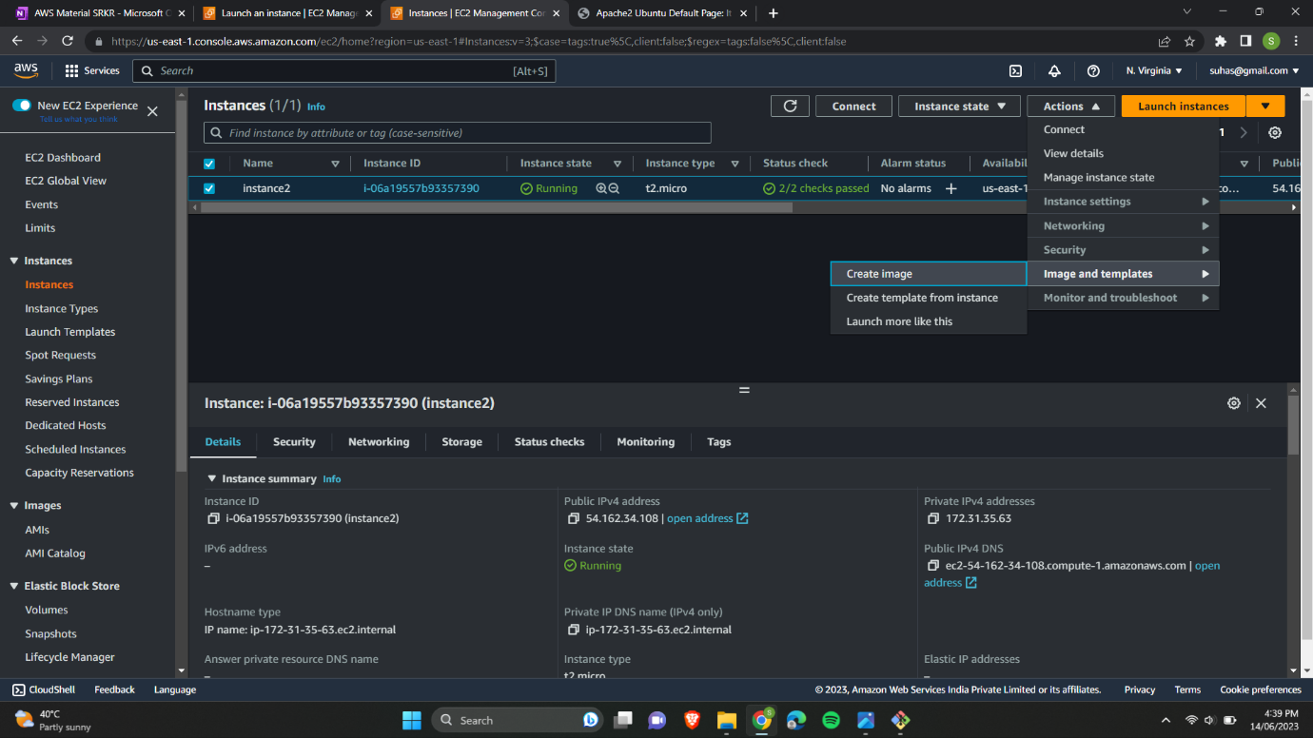3.By providing an image name and description we are creating the image for our instance.

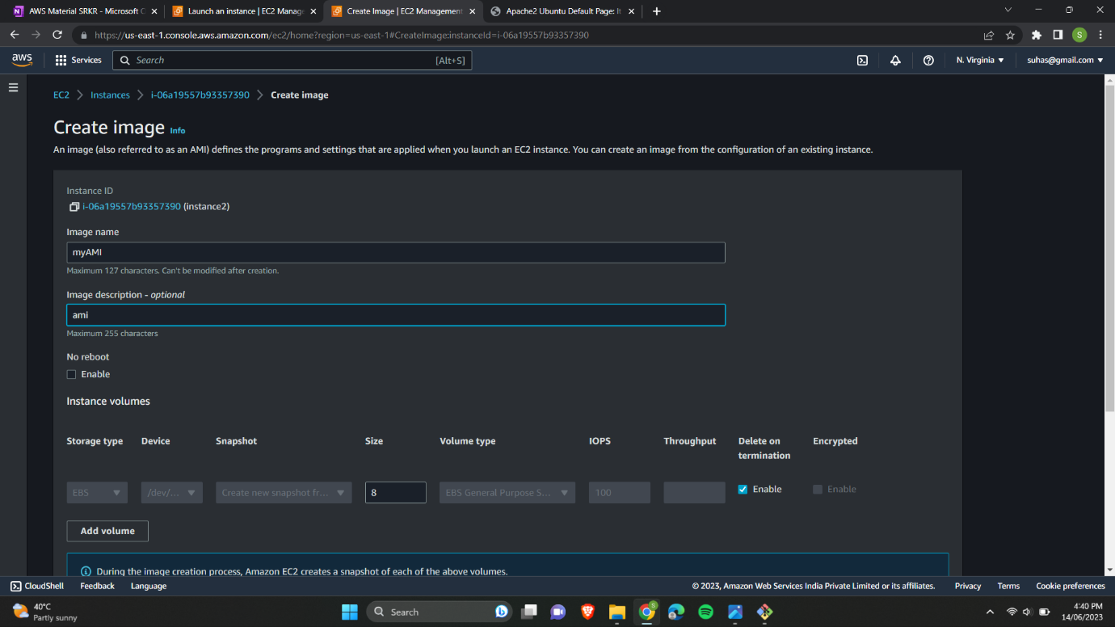

4. We can see the AMI we have created.

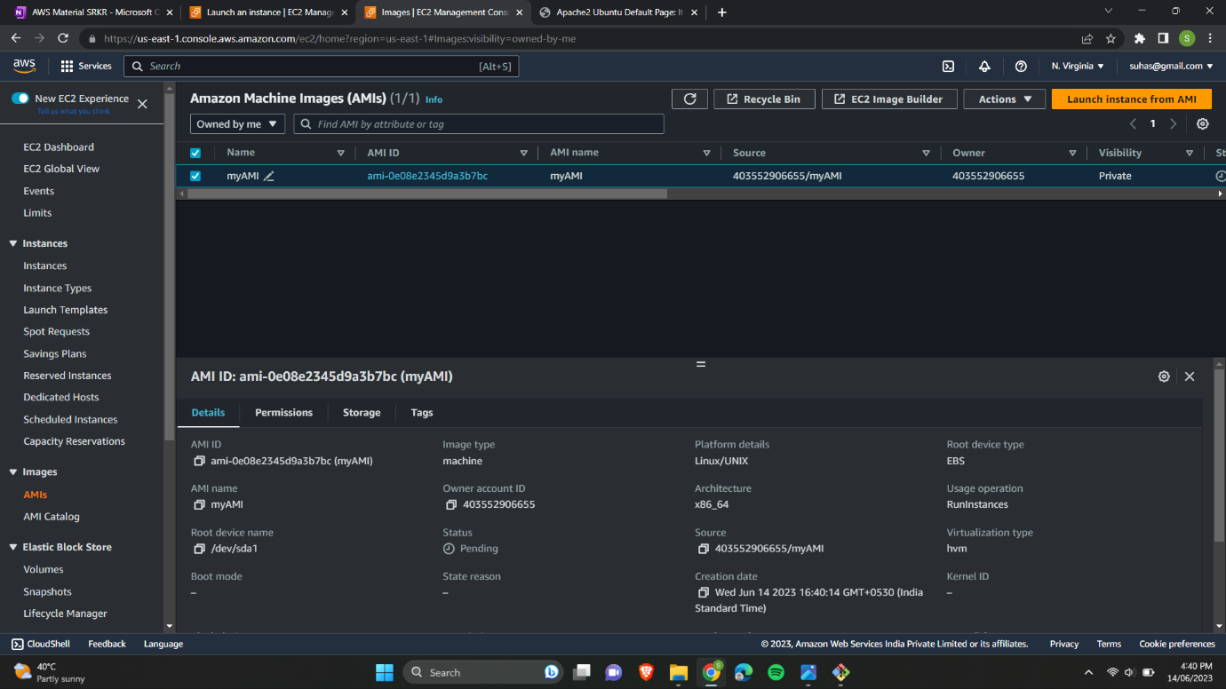

5.Now creating a new instance by providing the and at AMI we are selecting My AMIs option where we can choose our AMI that we have created.

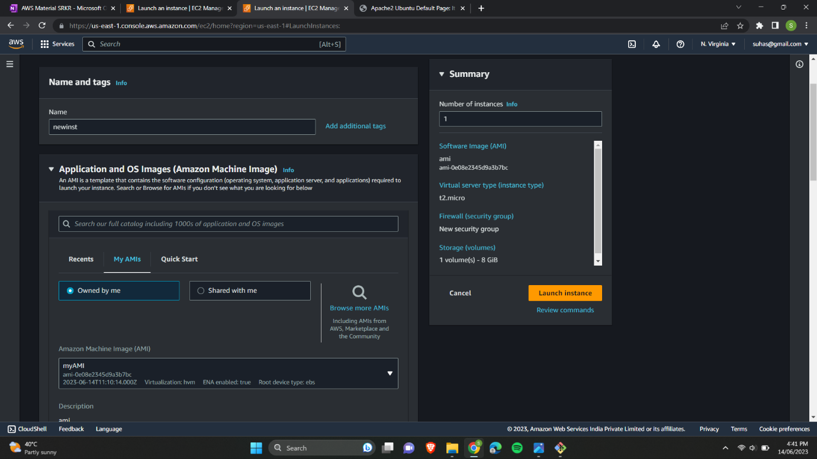

6.Selecting proceed without a keypair option for this instance because we are using the image of existing instance.

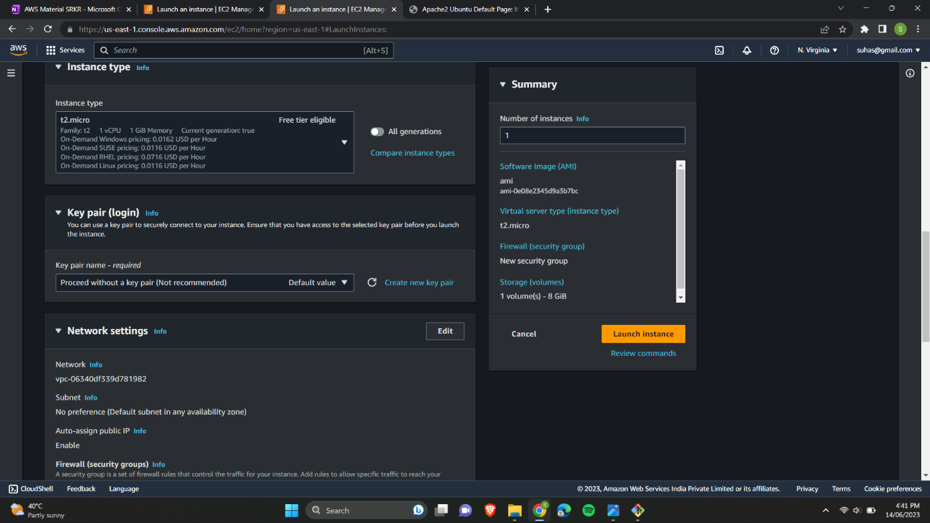

7. Only changing the security group to allow only HTTP traffic from the internet.

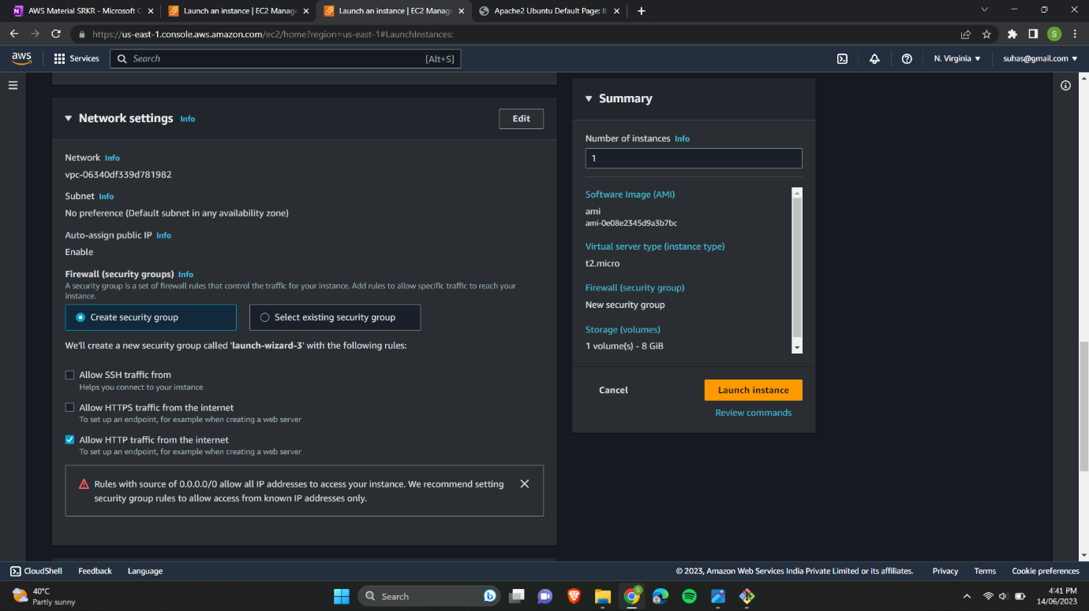

8.After creating the instance visiting the public IP of latest instance.

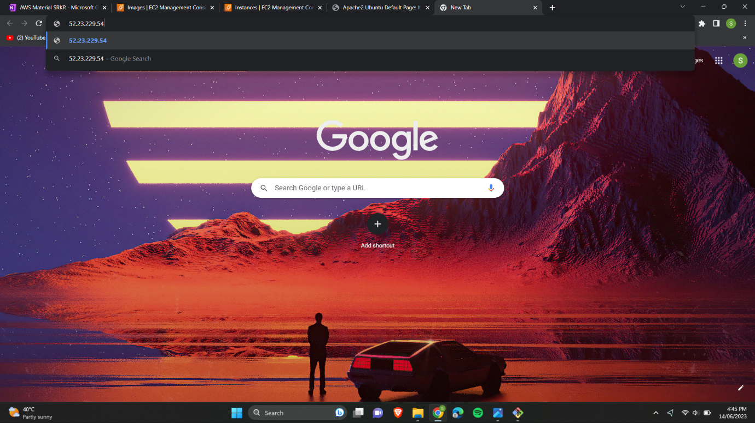

9.Here also we can see the apache2 default page even though we haven’t installed apache2 in this instance.

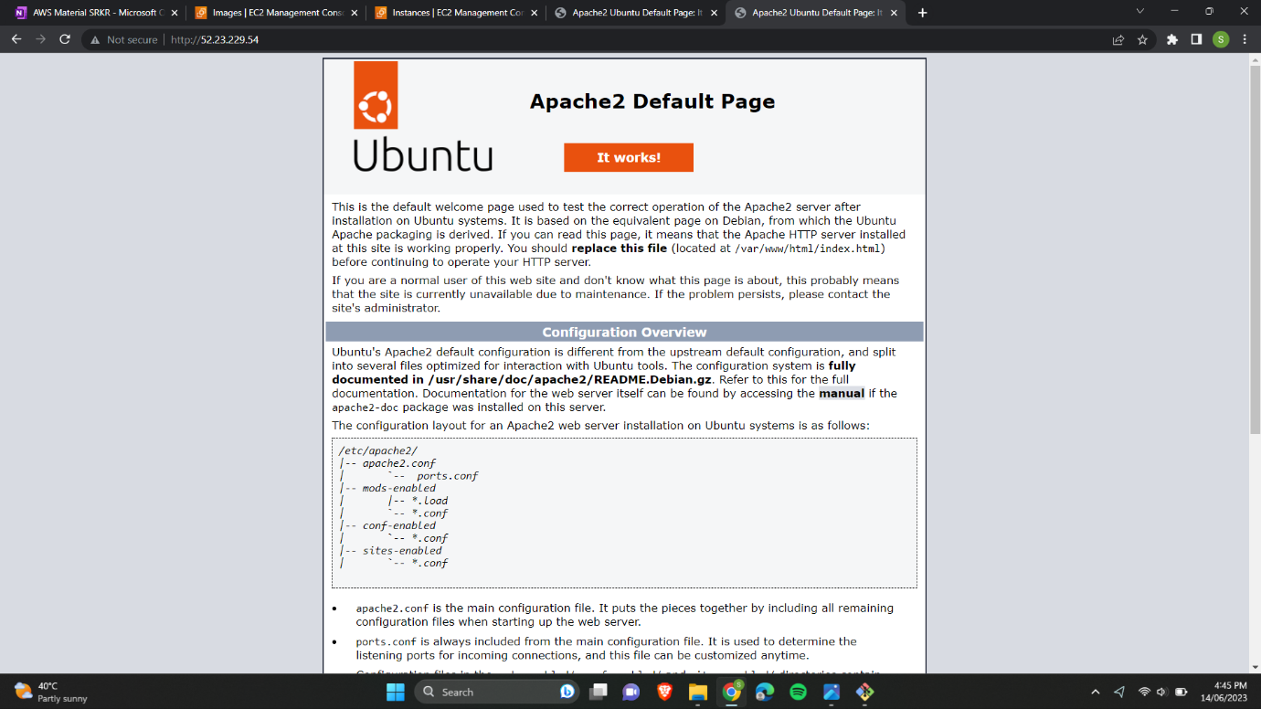

This is because of the AMI we have used during our instance creation.